**GEO TRACKING OF WASTE AND TRIGGERING ALERTS AND MAPPING AREAS WITH HIGH WASTE INDEX**

**ABSTRACT :**

This paper aims to improve the efficiency of the garbage collection process by developing a system for monitoring waste levels in garbage bins using ultrasonic sensors and connecting them to Arduino Uno board for sending the measurements like the amount of waste level to the user. Two smart dustbins were designed for home use and public use which are monitored in real-time using the mobile applications. Notification alerts are also sent when the amount of waste exceeds a certain threshold level. These dustbins are connected wirelessly using Zigbee based transceiver in the form of a mesh network to facilitate the transfer of the amount of waste present in these dustbins to the nearest garbage collection truck and an optimized shortest route to be followed by the garbage collector truck is calculated. The proposed system is user friendly, compact and cost-effective requiring minimum human intervention.

**INTRODUCTION :**

In India, sixty-two million tons of municipal solid waste is generated in cities and towns every year. Out of these, approximately forty-three million tons of waste is collected properly. Proper waste management is becoming a serious problem in developing countries resulting in deterioration of the environment and poor public health.

Several factors contribute to this improper management of waste collection and processing in India like dependence on the services of small labours or waste pickers for the collection of waste and extraction of any potential value from the waste. Mixed biodegradable and inert waste are often dumped together with e-waste without any segregation. These workers do not utilize any efficient method for processing and disposal of the waste and often practice open burning of the garbage.

Also, municipal corporations have budgets that are insufficient to cover the costs associated with developing the proper waste collection, storage, treatment and disposal. Local bodies spend around Rs. 500–1000 per tonne on solid waste management (SWM) with 70% of this amount spent on collection and 20% spent on transport [1].

In this work, an IoT based waste management system has been proposed for monitoring the waste levels in garbage bins across the city by recording these levels without any human intervention. The status of the dustbins is monitored via userfriendly applications. The locations and amount of waste present in these dustbins are used to determine the shortest possible route to be followed by the garbage collecting van which would help to reduce the cost of transportation and reduction of fuel consumption. The rest of the paper is organized as follows. The previous initiatives are discussed in Section II. The hardware and software design of the system is discussed in Section III and IV, respectively. System implementation and the related results are presented in Section V. Finally, the paper is concluded in Section VI.

**literacher survey:**

**Challenges and opportunities associated with waste management in India,"**

**AUTHORS :**

**Sunil Kumar, Stephen R. Smith, Geoff Fowler, Costas**

**ABSTRACT:**

India faces major environmental challenges associated with waste generation and inadequate waste collection, transport, treatment and disposal. Current systems in India cannot cope with the volumes of waste generated by an increasing urban population, and this impacts on the environment and public health. The challenges and barriers are significant, but so are the opportunities. This paper reports on an international seminar on ‘Sustainable solid waste management for cities: opportunities in South Asian Association for Regional Cooperation (SAARC) countries’ organized by the Council of Scientific and Industrial Research-National Environmental Engineering Research Institute and the Royal Society. A priority is to move from reliance on waste dumps that offer no environmental protection, to waste management systems that retain useful resources within the economy. Waste segregation at source and use of specialized waste processing facilities to separate recyclable materials has a key role. Disposal of residual waste after extraction of material resources needs engineered landfill sites and/or investment in waste-to-energy facilities. The potential for energy generation from landfill via methane extraction or thermal treatment is a major opportunity, but a key barrier is the shortage of qualified engineers and environmental professionals with the experience to deliver improved waste management systems in India.

**EXITING SYSTEM:**

The status of the bin, especially the fill percentage of the waste inside, should have less power consumption. Different methods used to monitor the level of waste in the dustbin are proposed by several authors, including an infrared sensor to measure the distance by reflecting light waves and ultrasonic sensor measures with the principle of reflected sound waves. Navghane et al. proposed a method to reduce the cost and increase the efficiency of waste applications [15]. A dustbin is interfaced with a microcontroller-based system with IR wireless systems and a central system displaying current garbage status. Therefore, the HTML page that updates the status can reduce human resources and efforts. Another GSM electronic monitoring system is proposed by Aasim et al., which sends SMS to the authority that the dustbin is fully filled to send the truck for trash collection [16]. Ultrasonic sensors were used to detect the amount of trash in the dustbin, and the GSM module was to provide information on the dustbin status. However, this system is only able to detect the top of the garbage level and cannot realize the space left in the dustbin.

To monitor the status of the bin, an energy-efficient telecommunication protocol that can travel far distances is important to be integrated in the smart waste management system. There are various kinds of telecommunication protocols available and each of them has its own strength and weakness in different situations. Smart garbage bins [17] enable approved persons to obtain information regarding the filling level via ultrasonic sensors and a GSM-equipped microcontroller that sends data to a control station. Another similar study [18] involves several sensors such as ultrasonic sensor, moisture sensor and gas sensor in its system to monitor the waste and condition of the bin. The ultrasonic sensor is used to monitor the garbage level. The wet waste can be detected by moisture sensors, and toxic gases can be detected through gas sensors. The microcontroller obtains the data from sensors and transmits them through the ZigBee transmitter at a long distance. Besides, the microcontroller also sends the SMS message to the mobile device through GSM. Apart from that, a sensor node for monitoring the waste bin filling level equipped with RFID technology is proposed in 2016, which could be a feasible solution due to its robustness and low cost [19]. However, 2G is not a long-term solution because it has a high running cost and will be eliminated in the future [20], causing the 2G telecommunication to stop servicing. This will lead to the disability to use IoT that communicates through GSM protocols. Table 1 shows the transmission range, spectrum used, bandwidth and maximum data rate of various Low Power Wide Area Network (LPWAN) technologies. LoRa provides a free spectrum under 1 GHz; meanwhile, it can transmit up to 15km. A system to monitor the overall condition of the dustbins plays an important role in a smart waste management system, where the authorities can monitor the overall situation of all dustbins in an easier method. Misra et al. proposed a waste management system that is monitored by the cloud [21]. From their experiment, ultrasonic sensors are used to sense the level of waste in the dustbin due to the longer range provided compared to IR sensors. Apart from that, IR sensors are also found to be affected by sunlight, object colour and object hardness. Their system is capable of sensing the amount of waste and the strength of biogas generated in the municipal area. The information gathered by sensors is sent to a server, where it is stored and processed over the internet. This data is then used to track the waste bins, and the correct choice is made by selecting the correct waste bin to be collected. The main features of this system are that it is designed to learn from experience and to draw conclusions not only on the status of the daily waste level. Apart from that, based on the experience, the system will predict the future situation, such as the availability of vehicles near the site and other factors involved. The overall cost and power consumption of this system is controlled very well, but it cannot recognize and separate the various types of waste in the dustbin.

Apart from that, Bhor et al. proposed a method for Smart Garbage Management in Smart Cities using IoT which can monitor the system through GUI [25]. The bins are integrated with ultrasonic sensors to detect the amount of garbage inside and a GSM system to communicate to the authorized control room. To have better control over the disposal of garbage, a GUI is built to track the desired details relevant to the garbage for various selected locations. This system ensures that waste in the dustbins are collected shortly after the amount of garbage reaches its limit. Apart from that, this system also eliminates corruption in the overall waste management system by detecting false reports. The vehicle garbage collection trips have been reduced and thereby reduces the overall waste collection budget. A smart waste management system requires automation to alert the authorities on the condition of the dustbins when the level of waste is almost or already full. A smart garbage alert system was proposed by Norfadzlia et al., which is an integrated system consisting of Arduino Uno, GSM Module, Ultrasonic sensor and LED light [26]. The ultrasonic sensors are used to detect two threshold levels which are 70% and 90% of the bin height. When the first threshold level is reached, the green LEDs will be switched on to alert the residents on that floor, and a first warning message is sent to the municipality. If the garbage level is then reached the second threshold level, the second warning message is sent to the municipality and red LEDs will be turned on to alert the residents. However, this system is limited and user friendly to users in flat residential areas or condominiums.

Another smart garbage alert system presented by Kumar et al. involves a microcontroller and IoT to alert the administrator. The system will alert a web server using a microcontroller and telecommunication module [27]. The microcontroller, Arduino UNO R3 is used to read data from an ultrasonic sensor. After the garbage crosses a certain level, it is configured to send a warning to the Thing Speak web server. For the verification process, an RFID reader is interconnected to the Arduino. Whenever the RFID reader is interrupted by an RFID tag (ID card of the cleaner), the ultrasonic sensor checks the dustbin’s status and sends it to the webserver. An android application is created to view the notification and status at the server end. The limitation of this system is the status of the bin can only be seen when the RFID tag is detected manually by the RFID reader, which is not user-friendly [28]. Due to the number of dustbins allocated in the urban areas is in a huge number, the power consumed by the dustbins and the system need to be handle properly to prevent overconsumption of resources. An article with title ‘A Low Power IoT Sensor Node Architecture for Waste Management Within Smart Cities Context’ focuses on the development of an Internet of Things (IoT) system to improve power-saving waste management in the context of Smart Cities [29]. An innovative typology of sensor nodes based on the use of low-cost and low-power components is defined. This node is integrated with a single-chip microcontroller, a sensor capable of measuring the filling level of the trash bins using ultrasound and a LoRa LPWAN (Low Power Large Area Network) technology-based data transmission module [22]. A minimal network architecture, based on a LoRa gateway, was built along with the node to test the performance of the IoT node. In particular, the paper analyses the node architecture in-depth, focusing on energy-saving technologies and policies, with the goal of extending battery life by reducing power consumption through optimization of hardware and software. Apart from that, the author also analyses the effectiveness of the sensor and radio module in the system. However, the proposed system does not categorize the waste automatically that leads to the biodegradable and non-biodegradable waste being mixed up in the bin.

The smart waste management system integrated with IoT only is not sufficient to achieve good management of waste. This is due to the waste not being categorized and separated in order to decide whether it can be recycled. An intelligent waste management system with a smart bin is necessary to manage a variety of waste materials. In artificial intelligence systems, object detection has been widely used. Recently, more studies have focused on improving the object detection techniques using deep machine learning, such as vehicle detection [30], face detection [31], and document image classification [32]. The most widely used technique is Convolutional Neural Network (CNN). Bobulski et al. created a waste classification system using image processing and CNN to classify various kinds of plastic garbage [33]. This plastic waste segregation system improves the efficiency of recycling by automating the sorting of materials, thus reducing the cost and simplifying the process. They developed a simpler and hence faster 15-layer network compared to AlexNet. This network has a shorter learning time, and in their research, this system categorized the waste into four main categories with very high accuracy. However, the proposed 15-layer network and AlexNet have less depth than other existing models, leading to difficulties learning features from image sets. Nowakowski et al. proposed an idea to identify and classify waste electrical and electronic equipment from photos by using an image recognition system [34]. The system involves users to improve the classification of the system by capturing their e-waste objects and upload them to the waste collection company server. The system will study the waste and enhance the waste collection preparation. This image recognition system can run on a server or via a mobile app. The authors proposed various methods for a different types of images. A convolutional neural network (CNN) based model is used to identify the type of e-waste; meanwhile, the category and size of waste are detected by a faster regionbased convolutional neural network (Faster R-CNN). CNN is good in image classification, while R-CNN is mainly for object detection. Yet, R-CNN must feed 2000 regions and apply CNN for each region, which consumes a lot of time to train for a large dataset and affect the speed of detection.

A deep neural network model, WasteNet, is proposed to improve waste classification accuracy [35]. This model is implemented on a Jetson Nano edge device which allows convenient deployment at the edge to permit smart bins to identify waste. On the TrashNet dataset, the WasteNet model has enhanced the accuracy of the system to 97%. This is a significant improvement on the original SVM method, which achieved 63% accuracy and an accuracy of 22% for CNN. Transfer learning is used on the WasteNet model to improve the baseline performance, speed up overall model development and training time. On the ImageNet dataset, the models which are trained for general image classification are used for transfer learning in this WasteNet model. A paper with title ‘‘Classification of Trash for Recyclability Status’’ is proposed [36]. A dataset named TrashNet is created and consists of 6 classes which are glass, paper, metal, plastic, cardboard, and trash. Each of the class has around 400-500 images and this dataset is released by them to the public. In this research, support vector machines (SVM) and convolutional neural networks (CNN) are used to test for this dataset on their performance. Based on the result of the research, CNN performs better than SVM. SVM has lower accuracy and limitation on the type of waste detectable. This is due to the simpler algorithm in SVM compared to the neural network, where a longer time is required to train the model to achieve optimal performance. Apart from that, Adedeji et al. proposed an intelligent waste classification system by combination of ResNet and SVM [37]. They used a 50-layer residual net pre-train (ResNet-50) CNN model to serve as the extractor of the system and Support Vector Machine (SVM) to categorize the waste into various groups such as glass, metal, paper, and plastic etc. A dataset of images of trash which was developed by Gary et al. is used to test the accuracy of this system, and an accuracy of 87% is achieved in this research. Wei-Lung et al. proposed an interesting idea in order to improve the accuracy of the classification of recycling waste [38]. TrashNet, a dataset consisting of six types of waste categories and contains up to 2527 waste pictures, was used in this research to test the CNNs’ performance. Data augmentation is applied to the dataset in order to significantly increase the diversity of data available for the training model and yet without collecting new data. Apart from that, a genetic algorithm (GA) is utilized in this research on the fully connected layer of DenseNet121. This can improve the accuracy of DenseNet121 on classification, and this optimized DenseNet121 achieved 99.6%, the highest accuracy in their research. From the papers reviewed, the proposed waste management systems are insufficient to solve the major challenges faced in cities. Most of the system proposed only has a single function, such as the system is only able to monitor the level of waste without method to alert the administrator. Apart from that, some systems only able to transmit the data of the bin in a short distance such as Wi-Fi protocol. The lack of classification and categorization of waste in the proposed system by many authors is also unable to solve the recycling problem existing.

**PROPOSED SYSTEM:**

**SMART WASTE MANAEMENT SYSTEM**

**A. SYSTEM MODEL DESIGN**

The design and dimensions of the bin are shown in Figure 1. The top compartment, also known as the electronic component compartment, stores most of the electronic components. The remaining compartments are used to store different types of waste. The waste thrown onto temporary waste placement will be detected by Raspberry Pi and then moved into the respective compartment by using servo motors.

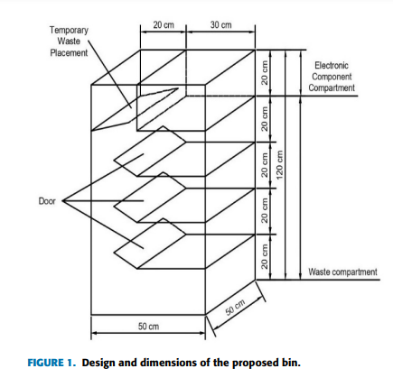 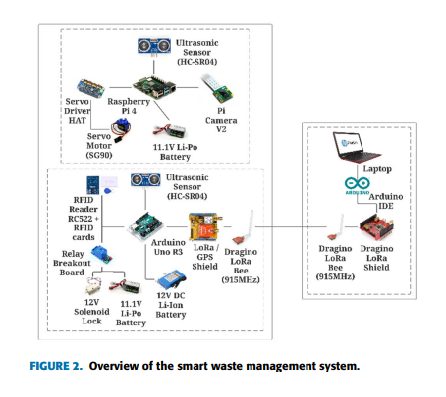

Figure 2 shows the overview of the smart waste management system. The development of a smart waste management system focuses on waste classification, categorization and bin status monitoring. There will be five major steps in developing the CNN-based object detection: choosing TensorFlow Lite over TensorFlow, the model and architecture of object detection, method of obtaining dataset, and method to export the trained model into hardware application. The waste classification and categorization system include CNN based object detection model and hardware such as Raspberry Pi, camera module, ultrasonic sensor and servo motors. Apart from that, the monitoring system of the bin is built on Arduino with ultrasonic sensors, GPS module and LoRa communication module with a written Arduino IDE sketch algorithm to obtain the real-time information of the bin from a further position. Besides, RFID based locker system is also integrated with the Arduino to protect the electronic components of the bin.

**B. OBJECT DETECTION MODEL:**

TensorFlow Lite is chosen over TensorFlow to be used on a low power mobile platform. This is due to most of the models trained on TensorFlow required a decent GPU to perform object detection. However, the requirement of a decent GPU is not applicable to the development of a smart bin. TensorFlow Lite allows the object detection models to be used on low power mobile devices such as Raspberry Pi. There are several pre-trained detection models on the COCO dataset provided by Tensorflow [39]. Several requirements need to be considered in choosing the suitable and optimum object detection model. The object detection model chosen is SSD MobileNetV2 Quantized 300×300, which is a COCO-trained model available in TensorFlow. Single Shot MultiBox Detector, also known as SSD, is specially designed for real-time object detection, which performs much faster and is lighter in terms of CPU usage. Figure 3 shows the architecture of the SSD MobileNet model, where the layers are simplified to improve the performance meanwhile maintain accuracy .

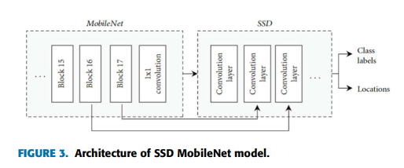

The SSD removes the region proposal network to increase the frame rate of object detection and implements several improvements such as multi-scale features and default boxes in order to improve the accuracy of the model. By using images with low resolution, such as 300 × 300 pixels, the time required to detect an object is hugely reduced. From the comparison in Table 2, SSD has the optimum mean average precision (mAP) and high frame rate among different detection models. Apart from the detection model, the CNN architecture of MobileNetV2 is designed to have decent classification performance on low power mobile devices. MobileNet architecture substantially lowers the network’s complex structure and model size. MobileNetV2 has a small architectural model size and low computing power compared to other networks shown in Table 3. The chosen model in the proposed system is quantized. Common neural networks consist of numerical values with high precision, which leads to tens or hundred of million of weights. The extremely large weights require a decent CPU, GPU or TPU to compute, which consume huge computing power and large memory. Quantization decreases the number of bits of image pixels without affecting the accuracy by replacing the high-precision numerical values with low-precision numerical values such as int and float. In this model, the 32-bit parameters is quantized to 8-bit, where the size and performance of the model are improved when performing detection. Two methods will be used to obtain the dataset, which is download from free sources and capture by phone with 12 megapixels camera module. The images will be obtained from free resources on Google Images. Due to the SSD MobileNetV2 Quantized 300 × 300, all the images in the waste dataset shall be 300 × 300 pixels. However, the resolution of images obtained are all in different sizes and format, thus an open-source software, Batch Image Resize is used to resize all the images to 300 × 300 pixels and output in JPEG image format. The training of the waste detection model is based on supervised learning, where the class of waste needs to be known by the network. In machine learning, the process is called labelling, which gives informative labels on the image to understand and learn from it. An open-source software, LabelImg is used to label the images into five categories, which are paper, cardboard, glass, plastic, and metal as shown in Figure 4 and Figure 5. Data augmentation is a method that uses existing training data to create new training data by applying several changes on the image. As CNN cannot verify the similarities of images with different conditions like rotated image, shifted image, flipped image and so on, data augmentation is useful in improving the accuracy of CNN model. A neural network library named Keras provides API (Application Programming Interface) to use data augmentation when training a model. There will be five main data augmentation techniques to be used which are image shifts, image flips, image brightness, image zoom and image rotations.

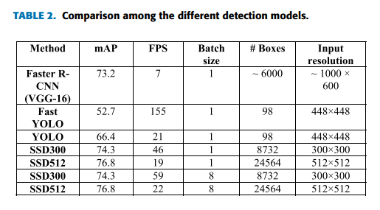

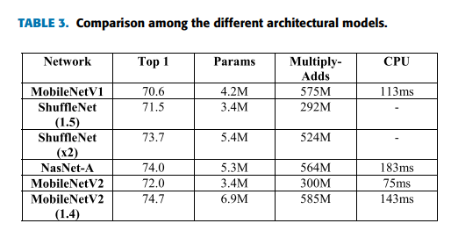

The training process of the object detection model required a decent GPU in order to have a better mean average precision result (mAP) and faster loss convergence. The higher computing power of GPU can increase the speed of training, and large memory of GPU can include more images to be trained at a time. Google Colab is chosen to train the CNN object detection model over a laptop because the GPUs available on Google Colab are the workstation cards, which are better than notebook GPUs in many aspects such as performance and memory size and bandwidth. The interface of Google Colab is shown in Figure 6. To improve the performance of waste detection model, hyperparameter tuning can be done with an optimizer. Adam optimizer will be used to tune the hyperparameters throughout the training process. Besides, the cosine decay learning rate, in which the learning rate will decay with the cosine function, is implemented in the training process to optimize the converging of the loss. Due to the limitation of the GPU memory, the optimum batch size of 16 is used. The hyperparameters that can be tuned with suitable settings are shown in Table 4, and the training configuration file is shown in Figure 7. In TensorFlow, the trained model can be exported as an inference graph which can be used to run object detection with python script. However, the inference graph cannot be implemented directly in the TensorFlow Lite interpreter due to the different format of the model. It must be converted by using TensorFlow Lite Optimizing Converter (TOCO). The usage of TOCO is required to build TensorFlow from the computer source.

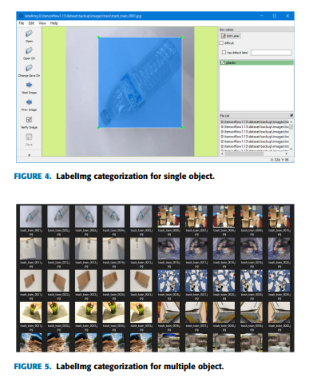

**C. WASTE CLASSIFICATION AND CATEGORIZATION SYSTEM :**

The development of waste classification and categorization required the integration of hardware with the CNN object detection trained model. The electronic components to be integrated into this system is listed in Table 5, and the diagram of the electronic component connection is shown in Figure 8. The type of waste will be categorized for respective compartments, shown in Table 6. Raspberry Pi 4 acts as the main processing centre for the waste classification and categorization system. The trained CNN waste detection model will be imported into Raspberry Pi 4 and integrated with the algorithms written in Python language to detect and control the movement of the waste. Pi Camera is used to work with the trained model to detect the waste that appeared in the range of the camera module with 8 megapixels. Pi Camera V2 is connected to Raspberry Pi 4 CSI camera port through the 15-pin connector, which required 3.3V to work. Apart from that, an ultrasonic sensor, HC-SR04, is used to detect the non-detectable waste within the waste placement area; therefore, the waste will be moved into Waste Compartment 4.

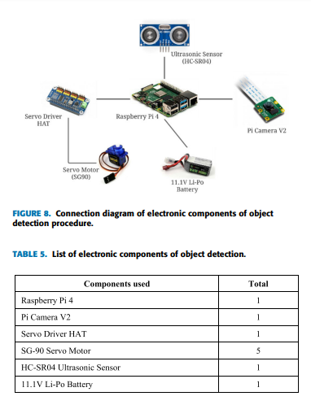

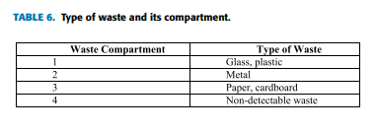

On the categorization part of the system, servo driver HAT and servo motors are used to move the waste into the waste compartment. The gear horn of the SG-90 servo motor is connected to a plastic board, act as a door to allow the waste to fall into the respective waste compartment. The SG-90 servo motor has a torque of 2.5kg/cm, which is sufficient to withstand most of the waste thrown on the plastic board and able to rotate clockwise and anticlockwise between 0◦ and 180◦ to move the waste in the desired direction. 4 servo motors are used to control the plastic board and one servo motor acts as the lock for the highest door of the bin. As each servo motor requires 5V to operate, Raspberry Pi 4 lacks sufficient 5V pins and pulse width modulation (PWM) pin. Therefore, an expansion board, servo driver HAT is a solution to the limitation of Raspberry Pi 4. Raspberry Pi 4 uses Pin 3 (SDA) and Pin 4 (SCL) to connect to servo driver HAT through I2C and is able to control five servo motors with the available 16 PWM outputs channel. Apart from that, the HAT is powered from an 11.1V Li-Po battery through the VIN terminal, which is also able to power on Raspberry Pi 4 through HAT.

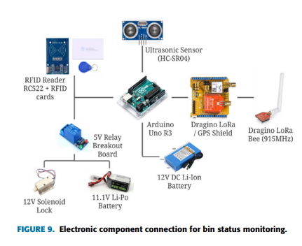

**D. BIN STATUS MONITORING AND LOCKER SYSTEM :**

The smart waste management system is not limited on classifying and categorizing the waste; meanwhile, it is able to monitor and track the condition of the bin from a long distance. Apart from that, electronics components stored in the top compartment of the bin are protected by installing RFID based locker system. There are two parts of the bin status monitoring process, where the bin acts as the client and the server is connected to the computer. The system on the bin monitors the status and location of the bin through sensors, send the information through LoRa communication and protect the electronic components compartment with RFID based locker. The server connected to the computer receives the information from the bin, allowing the administrator to monitor the bin. The list and connection of electronic components used are shown in Table 7 and Figure 9, respectively.

Arduino Uno R3 acts as the central processing microcontroller for the ultrasonic sensors, GPS module, LoRa module, RFID reader and solenoid lock. Arduino Uno has 14 digital input/output (I/O) pins and six analogue pins, which can perform like digital pins with certain commands in the Arduino IDE script. With the pins available on Arduino Uno, it can read from the sensors and modules to perform the bin monitoring and locker functions. A 12V DC Li-Ion battery is used to supply power to Arduino Uno through the DC power jack, which will be then regulated down to 5 volts and it is sufficient to supply current to the ultrasonic sensor, LoRa/GPS shield, RFID reader and a 5V relay breakout board. The fill level of waste in the bin needed to be monitored in real-time to improve the waste collection schedule, which prevents waste overflows or early collection. For this purpose, HC-SR04 ultrasonic sensors, Dragino Lora/GPS Shield and Dragino LoRa Bee (915 MHz) are connected to Arduino Uno. Four ultrasonic sensors are installed in each waste compartment respectively to monitor the waste fill level in real-time. The ultrasonic sensor is able to read a distance from 2cm to 400cm with an accuracy of 0.3cm, which is sufficient to read the fill level of waste in each waste compartment. The ultrasonic sensor uses sonar to determine the object distance. Firstly, the trigger pin of the ultrasonic sensor is set to high to emits a40 kHz high-frequency sound. The emitted sound wave travels through the air and bounces back when it meets an object. After 10 microseconds, the trigger pin is set to low and set echo pin to high using ‘PulseIn’ function of Arduino to measure the duration of reflected sound waves. The distance of the object can be calculated by using the measured duration and speed of sound in the air, which is 343m/s or 0.0343cm/µs at 20◦ . The formula is shown in Equation 1. An expansion board integrated with the LoRa module and GPS module is installed on Arduino Uno to track the GPS and transmit data through LoRa communication. L80 GPS, which is based on MTK MT3339, is used to calculate and predict the latitude and longitude of the bin by tracking at least three satellites for positioning. The GPS module can fix the location in a short amount of time even inside with low battery consumption due to automatically computed orbits that are saved for up to 3 days in internal flash. The serial interface UART is set to 9600 baud rate in the coding and initialized through Software Serial. The LoRa Bee connected on the shield is based on an SX1276 transceiver, which can transmit and receive at 915 MHz with high interference immunity whilst minimizing current consumption.

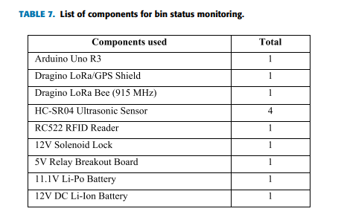

**HARDWARE & SOFTWARE REQUIREMENTS:**

**HARD REQUIRMENTS :**

* System    :   i3 or above.
* Ram    :   4 GB.
* Hard Disk : 40 GB

**SOFTWARE REQUIRMENTS :**

* Operating system   : Windows8 or Above.
* Coding Language  : python

# SYSTEM STUDY FEASIBILITY STUDY

The feasibility of the project is analyzed in this phase and business proposal is put forth with a very general plan for the project and some cost estimates. During system analysis the feasibility study of the proposed system is to be carried out. This is to ensure that the proposed system is not a burden to the company. For feasibility analysis, some understanding of the major requirements for the system is essential.

Three key considerations involved in the feasibility analysis are

* ECONOMICAL FEASIBILITY
* TECHNICAL FEASIBILITY
* SOCIAL FEASIBILITY

## ECONOMICAL FEASIBILITY

This study is carried out to check the economic impact that the system will have on the organization. The amount of fund that the company can pour into the research and development of the system is limited. The expenditures must be justified. Thus the developed system as well within the budget and this was achieved because most of the technologies used are freely available. Only the customized products had to be purchased.

## TECHNICAL FEASIBILITY

This study is carried out to check the technical feasibility, that is, the technical requirements of the system. Any system developed must not have a high demand on the available technical resources. This will lead to high demands on the available technical resources. This will lead to high demands being placed on the client. The developed system must have a modest requirement, as only minimal or null changes are required for implementing this system.

## SOCIAL FEASIBILITY

The aspect of study is to check the level of acceptance of the system by the user. This includes the process of training the user to use the system efficiently. The user must not feel threatened by the system, instead must accept it as a necessity. The level of acceptance by the users solely depends on the methods that are employed to educate the user about the system and to make him familiar with it. His level of confidence must be raised so that he is also able to make some constructive criticism, which is welcomed, as he is the final user of the system.

# 4.SYSTEM DESIGN

## 4.1 UML DIAGRAMS :

UML stands for Unified Modeling Language. UML is a standardized general-purpose modeling language in the field of object-oriented software engineering. The standard is managed, and was created by, the Object Management Group.

The goal is for UML to become a common language for creating models of object oriented computer software. In its current form UML is comprised of two major components: a Meta-model and a notation. In the future, some form of method or process may also be added to; or associated with, UML.

The Unified Modeling Language is a standard language for specifying, Visualization, Constructing and documenting the artifacts of software system, as well as for business modeling and other non-software systems.

The UML represents a collection of best engineering practices that have proven successful in the modeling of large and complex systems.

The UML is a very important part of developing objects oriented software and the software development process. The UML uses mostly graphical notations to express the design of software projects.

## GOALS:

The Primary goals in the design of the UML are as follows:

1. Provide users a ready-to-use, expressive visual modeling Language so that they can develop and exchange meaningful models.
2. Provide extendibility and specialization mechanisms to extend the core concepts.
3. Be independent of particular programming languages and development process.
4. Provide a formal basis for understanding the modeling language.
5. Encourage the growth of OO tools market.
6. Support higher level development concepts such as collaborations, frameworks, patterns and components.
7. Integrate best practices.

USE CASE DIAGRAM:

A use case diagram in the Unified Modeling Language (UML) is a type of behavioral diagram defined by and created from a Use-case analysis. Its purpose is to present a graphical overview of the functionality provided by a system in terms of actors, their goals (represented as use cases), and any dependencies between those use cases. The main purpose of a use case diagram is to show what system functions are performed for which actor. Roles of the actors in the system can be depicted.



# CLASS DIAGRAM:

In software engineering, a class diagram in the Unified Modeling Language (UML) is a type of static structure diagram that describes the structure of a system by showing the system's classes, their attributes, operations (or methods), and the relationships among the classes. It explains which class contains information.



SEQUENCE DIAGRAM:

A sequence diagram in Unified Modeling Language (UML) is a kind of interaction diagram that shows how processes operate with one another and in what order. It is a construct of a Message Sequence Chart. Sequence diagrams are sometimes called event diagrams, event scenarios, and timing diagrams.



COLLABRATION DIAGRAM:

Activity diagrams are graphical representations of workflows of stepwise activities and actions with support for choice, iteration and concurrency. In the Unified Modeling Language, activity diagrams can be used to describe the business and operational step-by-step workflows of components in a system. An activity diagram shows the overall flow of control.

IMPLEMENTATION:

## MODULES:

This project consists of two modules

User Module: In this module user can upload waste images and add location details.

Here student asking to display location in map but the problem is to display location in map we need to have latitude and longitude values then only we can display exact location in map and we don’t have any sensor or devices to track latitude and longitude. So we can’t use maps.

Waste Collector Module: In this module waste collectors will upload video and this video will start playing and we need to consider this video as its playing from webcam or drone. Video player continuously scan images to find pattern match between current location and user uploaded waste images. If pattern in video matched with user uploaded waste images then application will inform to waste collector via bounding boxes.

Note: here we are matching images using pattern match technique which is not 100% reliable for matching. If two different images having little similar pattern or colour then this technique will detect the match. So sometime two different images can also raise output as match.

SOFTWARE ENVIRONMENT

## What is Python :

Below are some facts about Python.

Python is currently the most widely used multi-purpose, high-level programming language.

Python allows programming in Object-Oriented and Procedural paradigms. Python programs generally are smaller than other programming languages like Java.

Programmers have to type relatively less and indentation requirement of the language, makes them readable all the time.

Python language is being used by almost all tech-giant companies like – Google, Amazon, Facebook, Instagram, Dropbox, Uber… etc.

The biggest strength of Python is huge collection of standard library which can be used for the following –

* + [Machine Learning](https://www.geeksforgeeks.org/machine-learning/)
  + GUI Applications (like Kivy, Tkinter, PyQt etc. )
  + Web frameworks like Django (used by YouTube, Instagram, Dropbox)
  + Image processing (like Opencv, Pillow)
  + Web scraping (like Scrapy, BeautifulSoup, Selenium)
  + Test frameworks
  + Multimedia

## Advantages of Python :-

Let’s see how Python dominates over other languages.

## 1. Extensive Libraries

Python downloads with an extensive library and it contain code for various purposes like regular expressions, documentation-generation, unit-testing, web browsers, threading, databases, CGI, email, image manipulation, and more. So, we don’t have to write the complete code for that manually.

## 2. Extensible

As we have seen earlier, Python can be**extended to other languages**. You can write some of your code in languages like C++ or C. This comes in handy, especially in projects.

## 3. Embeddable

Complimentary to extensibility, Python is embeddable as well. You can put your Python code in your source code of a different language, like C++. This lets us add **scripting capabilities**to our code in the other language.

## 4. Improved Productivity

The language’s simplicity and extensive libraries render programmers**more productive** than languages like Java and C++ do. Also, the fact that you need to write less and get more things done.

## 5. IOT Opportunities

Since Python forms the basis of new platforms like Raspberry Pi, it finds the future bright for the Internet Of Things. This is a way to connect the language with the real world.

When working with Java, you may have to create a class to print **‘Hello World’**. But in Python, just a print statement will do. It is also quite **easy to learn, understand,** and**code.** This is why when people pick up Python, they have a hard time adjusting to other more verbose languages like Java.

## 7. Readable

Because it is not such a verbose language, reading Python is much like reading English. This is the reason why it is so easy to learn, understand, and code. It also does not need curly braces to define blocks, and **indentation is mandatory.** This further aids the readability of the code.

## 8. Object-Oriented

This language supports both the **procedural and object-oriented**programming paradigms. While functions help us with code reusability, classes and objects let us model the real world. A class allows the **encapsulation of data** and functions into one.

## 9. Free and Open-Source

Like we said earlier, Python is **freely available.** But not only can you[**download Python**](https://data-flair.training/blogs/install-python-windows/) for free, but you can also download its source code, make changes to it, and even distribute it. It downloads with an extensive collection of libraries to help you with your tasks.

#### 10. Portable

When you code your project in a language like C++, you may need to make some changes to it if you want to run it on another platform. But it isn’t the same with Python. Here, you need to**code only once**, and you can run it anywhere. This is called **Write Once Run Anywhere (WORA)**. However, you need to be careful enough not to include any system-dependent features.

## 11. Interpreted

Lastly, we will say that it is an interpreted language. Since statements are executed one by one, **debugging is easier** than in compiled languages.

Any doubts till now in the advantages of Python? Mention in the comment section.

# Advantages of Python Over Other Languages :

## 1. Less Coding

Almost all of the tasks done in Python requires less coding when the same task is done in other languages. Python also has an awesome standard library support, so you don’t have to search for any third-party libraries to get your job done. This is the reason that many people suggest learning Python to beginners.

## 2. Affordable

Python is free therefore individuals, small companies or big organizations can leverage the free available resources to build applications. Python is popular and widely used so it gives you better community support.

**The 2019 Github annual survey showed us that Python has overtaken Java in the most popular programming language category.**

## 3. Python is for Everyone

Python code can run on any machine whether it is Linux, Mac or Windows. Programmers need to learn different languages for different jobs but with Python, you can professionally build web apps, perform data analysis and [**machine learning**](https://data-flair.training/blogs/machine-learning-tutorials-home/), automate things, do web scraping and also build games and powerful visualizations. It is an all-rounder programming language.

## Disadvantages of Python

So far, we’ve seen why Python is a great choice for your project. But if you choose it, you should be aware of its consequences as well. Let’s now see the downsides of choosing Python over another language.

#### 1. Speed Limitations

We have seen that Python code is executed line by line. But since [Python](https://www.python.org/) is interpreted, it often results in **slow execution**. This, however, isn’t a problem unless speed is a focal point for the project. In other words, unless high speed is a requirement, the benefits offered by Python are enough to distract us from its speed limitations.

#### 2. Weak in Mobile Computing and Browsers

While it serves as an excellent server-side language, Python is much rarely seen on the **client-side**. Besides that, it is rarely ever used to implement smartphone-based applications. One such application is called **Carbonnelle**.

The reason it is not so famous despite the existence of Brython is that it isn’t that secure.

#### 3. Design Restrictions

As you know, Python is **dynamically-typed**. This means that you don’t need to declare the type of variable while writing the code. It uses **duck-typing**. But wait, what’s that? Well, it just means that if it looks like a duck, it must be a duck. While this is easy on the programmers during coding, it can**raise run-time errors**.

#### 4. Underdeveloped Database Access Layers

Compared to more widely used technologies like **JDBC (Java DataBase Connectivity)** and **ODBC (Open DataBase Connectivity)**, Python’s database access layers are a bit underdeveloped. Consequently, it is less often applied in huge enterprises.

#### 5. Simple

No, we’re not kidding. Python’s simplicity can indeed be a problem. Take my example. I don’t do Java, I’m more of a Python person. To me, its syntax is so simple that the verbosity of Java code seems unnecessary.

This was all about the Advantages and Disadvantages of Python Programming Language.

## History of Python : -

What do the alphabet and the programming language Python have in common? Right, both start with ABC. If we are talking about ABC in the Python context, it's clear that the programming language ABC is meant. ABC is a general-purpose programming language and programming environment, which had been developed in the Netherlands, Amsterdam, at the CWI (Centrum Wiskunde &Informatica). The greatest achievement of ABC was to influence the design of Python.Python was conceptualized in the late 1980s. Guido van Rossum worked that time in a project at the CWI, called Amoeba, a distributed operating system. In an interview with Bill Venners1, Guido van Rossum said: "In the early 1980s, I worked as an implementer on a team building a language called ABC at Centrum voor Wiskunde en Informatica (CWI). I don't know how well people know ABC's influence on Python. I try to mention ABC's influence because I'm indebted to everything I learned during that project and to the people who worked on it."Later on in the same Interview, Guido van Rossum continued: "I remembered all my experience and some of my frustration with ABC. I decided to try to design a simple scripting language that possessed some of ABC's better properties, but without its problems. So I started typing. I created a simple virtual machine, a simple parser, and a simple runtime. I made my own version of the various ABC parts that I liked. I created a basic syntax, used indentation for statement grouping instead of curly braces or begin-end blocks, and developed a small number of powerful data types: a hash table (or dictionary, as we call it), a list, strings, and numbers."

## What is Machine Learning : -

Before we take a look at the details of various machine learning methods, let's start by looking at what machine learning is, and what it isn't. Machine learning is often categorized as a subfield of artificial intelligence, but I find that categorization can often be misleading at first brush. The study of machine learning certainly arose from research in this context, but in the data science application of machine learning methods, it's more helpful to think of machine learning as a means of building models of data.

Fundamentally, machine learning involves building mathematical models to help understand data. "Learning" enters the fray when we give these models tunable parameters that can be adapted to observed data; in this way the program can be considered to be "learning" from the data. Once these models have been fit to previously seen data, they can be used to predict and understand aspects of newly observed data. I'll leave to the reader the more philosophical digression regarding the extent to which this type of mathematical, model-based "learning" is similar to the "learning" exhibited by the human brain.Understanding the problem setting in machine learning is essential to using these tools effectively, and so we will start with some broad categorizations of the types of approaches we'll discuss here.

## Categories Of Machine Leaning :-

At the most fundamental level, machine learning can be categorized into two main types: supervised learning and unsupervised learning.

Supervised learning involves somehow modeling the relationship between measured features of data and some label associated with the data; once this model is determined, it can be used to apply labels to new, unknown data. This is further subdivided into classification tasks and regression tasks: in classification, the labels are discrete categories, while in regression, the labels are continuous quantities. We will see examples of both types of supervised learning in the following section.

Unsupervised learning involves modeling the features of a dataset without reference to any label, and is often described as "letting the dataset speak for itself." These models include tasks such as clustering and dimensionality reduction. Clustering algorithms identify distinct groups of data, while dimensionality reduction algorithms search for more succinct representations of the data. We will see examples of both types of unsupervised learning in the following section.

## Need for Machine Learning

Human beings, at this moment, are the most intelligent and advanced species on earth because they can think, evaluate and solve complex problems. On the other side, AI is still in its initial stage and haven’t surpassed human intelligence in many aspects. Then the question is that what is the need to make machine learn? The most suitable reason for doing this is, “to make decisions, based on data, with efficiency and scale”.

Lately, organizations are investing heavily in newer technologies like Artificial Intelligence, Machine Learning and Deep Learning to get the key information from data to perform several real-world tasks and solve problems. We can call it data-driven decisions taken by machines, particularly to automate the process. These data-driven decisions can be used, instead of using programing logic, in the problems that cannot be programmed inherently. The fact is that we can’t do without human intelligence, but other aspect is that we all need to solve real-world problems with efficiency at a huge scale. That is why the need for machine learning arises.

## Challenges in Machines Learning :-

While Machine Learning is rapidly evolving, making significant strides with cybersecurity and autonomous cars, this segment of AI as whole still has a long way to go. The reason behind is that ML has not been able to overcome number of challenges. The challenges that ML is facing currently are −

**Quality of data** − Having good-quality data for ML algorithms is one of the biggest challenges. Use of low-quality data leads to the problems related to data preprocessing and feature extraction.

**Time-Consuming task** − Another challenge faced by ML models is the consumption of time especially for data acquisition, feature extraction and retrieval.

**Lack of specialist persons** − As ML technology is still in its infancy stage, availability of expert resources is a tough job.

**No clear objective for formulating business problems** − Having no clear objective and well-defined goal for business problems is another key challenge for ML because this technology is not that mature yet.

**Issue of overfitting & underfitting** − If the model is overfitting or underfitting, it cannot be represented well for the problem.

**Curse of dimensionality** − Another challenge ML model faces is too many features of data points. This can be a real hindrance.

**Difficulty in deployment** − Complexity of the ML model makes it quite difficult to be deployed in real life.

## Applications of Machines Learning :-

Machine Learning is the most rapidly growing technology and according to researchers we are in the golden year of AI and ML. It is used to solve many real-world complex problems which cannot be solved with traditional approach. Following are some real-world applications of ML −

* Emotion analysis
* Sentiment analysis
* Error detection and prevention
* Weather forecasting and prediction
* Stock market analysis and forecasting
* Speech synthesis
* Speech recognition
* Customer segmentation
* Object recognition
* Fraud detection
* Fraud prevention
* Recommendation of products to customer in online shopping

# How to Start Learning Machine Learning?

Arthur Samuel coined the term **“Machine Learning”** in 1959 and defined it as a **“Field of study that gives computers the capability to learn without being explicitly programmed”.**

And that was the beginning of Machine Learning! In modern times, Machine Learning is one of the most popular (if not the most!) career choices. According to [Indeed](http://blog.indeed.com/2019/03/14/best-jobs-2019/), Machine Learning Engineer Is The Best Job of 2019 with a 344% growth and an average base salary of **$146,085** per year.

But there is still a lot of doubt about what exactly is Machine Learning and how to start learning it? So this article deals with the Basics of Machine Learning and also the path you can follow to eventually become a full-fledged Machine Learning Engineer. Now let’s get started!!!

### How to start learning ML?

This is a rough roadmap you can follow on your way to becoming an insanely talented Machine Learning Engineer. Of course, you can always modify the steps according to your needs to reach your desired end-goal!

### Step 1 – Understand the Prerequisites

In case you are a genius, you could start ML directly but normally, there are some prerequisites that you need to know which include Linear Algebra, Multivariate Calculus, Statistics, and Python. And if you don’t know these, never fear! You don’t need a Ph.D. degree in these topics to get started but you do need a basic understanding.

#### (a) Learn Linear Algebra and Multivariate Calculus

Both Linear Algebra and Multivariate Calculus are important in Machine Learning. However, the extent to which you need them depends on your role as a data scientist. If you are more focused on application heavy machine learning, then you will not be that heavily focused on maths as there are many common libraries available. But if you want to focus on R&D in Machine Learning, then mastery of Linear Algebra and Multivariate Calculus is very important as you will have to implement many ML algorithms from scratch.

#### (b) Learn Statistics

Data plays a huge role in Machine Learning. In fact, around 80% of your time as an ML expert will be spent collecting and cleaning data. And statistics is a field that handles the collection, analysis, and presentation of data. So it is no surprise that you need to learn it!!!  
Some of the key concepts in statistics that are important are Statistical Significance, Probability Distributions, Hypothesis Testing, Regression, etc. Also, Bayesian Thinking is also a very important part of ML which deals with various concepts like Conditional Probability, Priors, and Posteriors, Maximum Likelihood, etc.

#### (c) Learn Python

Some people prefer to skip Linear Algebra, Multivariate Calculus and Statistics and learn them as they go along with trial and error. But the one thing that you absolutely cannot skip is [Python](https://www.geeksforgeeks.org/python-programming-language/)! While there are other languages you can use for Machine Learning like R, Scala, etc. Python is currently the most popular language for ML. In fact, there are many Python libraries that are specifically useful for Artificial Intelligence and Machine Learning such as [Keras](https://keras.io/" \t "_blank), [TensorFlow](https://www.tensorflow.org/" \t "_blank), [Scikit-learn](https://scikit-learn.org/stable/" \t "_blank), etc.

So if you want to learn ML, it’s best if you learn Python! You can do that using various online resources and courses such as [**Fork Python**](https://practice.geeksforgeeks.org/courses/fork-python) available Free on GeeksforGeeks.

### Step 2 – Learn Various ML Concepts

Now that you are done with the prerequisites, you can move on to actually learning ML (Which is the fun part!!!) It’s best to start with the basics and then move on to the more complicated stuff. Some of the basic concepts in ML are:

#### (a) Terminologies of Machine Learning

* **Model –**A model is a specific representation learned from data by applying some machine learning algorithm. A model is also called a hypothesis.
* **Feature –**A feature is an individual measurable property of the data. A set of numeric features can be conveniently described by a feature vector. Feature vectors are fed as input to the model. For example, in order to predict a fruit, there may be features like color, smell, taste, etc.
* **Target (Label) –**A target variable or label is the value to be predicted by our model. For the fruit example discussed in the feature section, the label with each set of input would be the name of the fruit like apple, orange, banana, etc.
* **Training –**The idea is to give a set of inputs(features) and it’s expected outputs(labels), so after training, we will have a model (hypothesis) that will then map new data to one of the categories trained on.
* **Prediction –**Once our model is ready, it can be fed a set of inputs to which it will provide a predicted output(label).

#### (b) Types of Machine Learning

* **Supervised Learning –**This involves learning from a training dataset with labeled data using classification and regression models. This learning process continues until the required level of performance is achieved.
* **Unsupervised Learning –**This involves using unlabelled data and then finding the underlying structure in the data in order to learn more and more about the data itself using factor and cluster analysis models.
* **Semi-supervised Learning –**This involves using unlabelled data like Unsupervised Learning with a small amount of labeled data. Using labeled data vastly increases the learning accuracy and is also more cost-effective than Supervised Learning.
* **Reinforcement Learning –**This involves learning optimal actions through trial and error. So the next action is decided by learning behaviors that are based on the current state and that will maximize the reward in the future.

### Advantages of Machine learning :-

#### 1. Easily identifies trends and patterns -

Machine Learning can review large volumes of data and discover specific trends and patterns that would not be apparent to humans. For instance, for an e-commerce website like Amazon, it serves to understand the browsing behaviors and purchase histories of its users to help cater to the right products, deals, and reminders relevant to them. It uses the results to reveal relevant advertisements to them.

#### 2. No human intervention needed (automation)

With ML, you don’t need to babysit your project every step of the way. Since it means giving machines the ability to learn, it lets them make predictions and also improve the algorithms on their own. A common example of this is anti-virus softwares; they learn to filter new threats as they are recognized. ML is also good at recognizing spam.

#### 3. Continuous Improvement

As [**ML algorithms**](https://data-flair.training/blogs/machine-learning-algorithms/) gain experience, they keep improving in accuracy and efficiency. This lets them make better decisions. Say you need to make a weather forecast model. As the amount of data you have keeps growing, your algorithms learn to make more accurate predictions faster.

#### 4. Handling multi-dimensional and multi-variety data

Machine Learning algorithms are good at handling data that are multi-dimensional and multi-variety, and they can do this in dynamic or uncertain environments.

#### 5. Wide Applications

You could be an e-tailer or a healthcare provider and make ML work for you. Where it does apply, it holds the capability to help deliver a much more personal experience to customers while also targeting the right customers.

### Disadvantages of Machine Learning :-

#### 1. Data Acquisition

Machine Learning requires massive data sets to train on, and these should be inclusive/unbiased, and of good quality. There can also be times where they must wait for new data to be generated.

#### 2. Time and Resources

ML needs enough time to let the algorithms learn and develop enough to fulfill their purpose with a considerable amount of accuracy and relevancy. It also needs massive resources to function. This can mean additional requirements of computer power for you.

#### 3. Interpretation of Results

Another major challenge is the ability to accurately interpret results generated by the algorithms. You must also carefully choose the algorithms for your purpose.

#### 4. High error-susceptibility

[Machine Learning](https://en.wikipedia.org/wiki/Machine_learning) is autonomous but highly susceptible to errors. Suppose you train an algorithm with data sets small enough to not be inclusive. You end up with biased predictions coming from a biased training set. This leads to irrelevant advertisements being displayed to customers. In the case of ML, such blunders can set off a chain of errors that can go undetected for long periods of time. And when they do get noticed, it takes quite some time to recognize the source of the issue, and even longer to correct it.

**Python Development Steps : -**

Guido Van Rossum published the first version of Python code (version 0.9.0) at alt.sources in February 1991. This release included already exception handling, functions, and the core data types of list, dict, str and others. It was also object oriented and had a module system.  
Python version 1.0 was released in January 1994. The major new features included in this release were the functional programming tools lambda, map, filter and reduce, which Guido Van Rossum never liked.Six and a half years later in October 2000, Python 2.0 was introduced. This release included list comprehensions, a full garbage collector and it was supporting unicode.Python flourished for another 8 years in the versions 2.x before the next major release as Python 3.0 (also known as "Python 3000" and "Py3K") was released. Python 3 is not backwards compatible with Python 2.x. The emphasis in Python 3 had been on the removal of duplicate programming constructs and modules, thus fulfilling or coming close to fulfilling the 13th law of the Zen of Python: "There should be one -- and preferably only one -- obvious way to do it."Some changes in Python 7.3:

* Print is now a function
* Views and iterators instead of lists
* The rules for ordering comparisons have been simplified. E.g. a heterogeneous list cannot be sorted, because all the elements of a list must be comparable to each other.
* There is only one integer type left, i.e. int. long is int as well.
* The division of two integers returns a float instead of an integer. "//" can be used to have the "old" behaviour.
* Text Vs. Data Instead Of Unicode Vs. 8-bit

**Purpose :-**

We demonstrated that our approach enables successful segmentation of intra-retinal layers—even with low-quality images containing speckle noise, low contrast, and different intensity ranges throughout—with the assistance of the ANIS feature.

**Python**

Python is an interpreted high-level programming language for general-purpose programming. Created by Guido van Rossum and first released in 1991, Python has a design philosophy that emphasizes code readability, notably using significant whitespace.

Python features a dynamic type system and automatic memory management. It supports multiple programming paradigms, including object-oriented, imperative, functional and procedural, and has a large and comprehensive standard library.

* Python is Interpreted − Python is processed at runtime by the interpreter. You do not need to compile your program before executing it. This is similar to PERL and PHP.
* Python is Interactive − you can actually sit at a Python prompt and interact with the interpreter directly to write your programs.

Python also acknowledges that speed of development is important. Readable and terse code is part of this, and so is access to powerful constructs that avoid tedious repetition of code. Maintainability also ties into this may be an all but useless metric, but it does say something about how much code you have to scan, read and/or understand to troubleshoot problems or tweak behaviors. This speed of development, the ease with which a programmer of other languages can pick up basic Python skills and the huge standard library is key to another area where Python excels. All its tools have been quick to implement, saved a lot of time, and several of them have later been patched and updated by people with no Python background - without breaking.

**Modules Used in Project :-**

**Tensorflow**

TensorFlow is a [free](https://en.wikipedia.org/wiki/Free_software) and [open-source](https://en.wikipedia.org/wiki/Open-source_software) [software library for dataflow and differentiable programming](https://en.wikipedia.org/wiki/Library_(computing)) across a range of tasks. It is a symbolic math library, and is also used for [machine learning](https://en.wikipedia.org/wiki/Machine_learning) applications such as [neural networks](https://en.wikipedia.org/wiki/Neural_networks). It is used for both research and production at [Google](https://en.wikipedia.org/wiki/Google).‍

TensorFlow was developed by the [Google Brain](https://en.wikipedia.org/wiki/Google_Brain) team for internal Google use. It was released under the [Apache 2.0](https://en.wikipedia.org/wiki/Apache_License) [open-source license](https://en.wikipedia.org/wiki/Open-source_license) on November 9, 2015.

**Numpy**

Numpy is a general-purpose array-processing package. It provides a high-performance multidimensional array object, and tools for working with these arrays.

It is the fundamental package for scientific computing with Python. It contains various features including these important ones:

* A powerful N-dimensional array object
* Sophisticated (broadcasting) functions
* Tools for integrating C/C++ and Fortran code
* Useful linear algebra, Fourier transform, and random number capabilities

Besides its obvious scientific uses, Numpy can also be used as an efficient multi-dimensional container of generic data. Arbitrary data-types can be defined using Numpy which allows Numpy to seamlessly and speedily integrate with a wide variety of databases.

**Pandas**

Pandas is an open-source Python Library providing high-performance data manipulation and analysis tool using its powerful data structures. Python was majorly used for data munging and preparation. It had very little contribution towards data analysis. Pandas solved this problem. Using Pandas, we can accomplish five typical steps in the processing and analysis of data, regardless of the origin of data load, prepare, manipulate, model, and analyze. Python with Pandas is used in a wide range of fields including academic and commercial domains including finance, economics, Statistics, analytics, etc.

**Matplotlib**

Matplotlib is a Python 2D plotting library which produces publication quality figures in a variety of hardcopy formats and interactive environments across platforms. Matplotlib can be used in Python scripts, the Python and [IPython](http://ipython.org/) shells, the [Jupyter](http://jupyter.org/) Notebook, web application servers, and four graphical user interface toolkits. Matplotlib tries to make easy things easy and hard things possible. You can generate plots, histograms, power spectra, bar charts, error charts, scatter plots, etc., with just a few lines of code. For examples, see the [sample plots](https://matplotlib.org/tutorials/introductory/sample_plots.html) and [thumbnail gallery](https://matplotlib.org/gallery/index.html).

For simple plotting the pyplot module provides a MATLAB-like interface, particularly when combined with IPython. For the power user, you have full control of line styles, font properties, axes properties, etc, via an object oriented interface or via a set of functions familiar to MATLAB users.

**Scikit – learn**

Scikit-learn provides a range of supervised and unsupervised learning algorithms via a consistent interface in Python. It is licensed under a permissive simplified BSD license and is distributed under many Linux distributions, encouraging academic and commercial use. **Python**

Python is an interpreted high-level programming language for general-purpose programming. Created by Guido van Rossum and first released in 1991, Python has a design philosophy that emphasizes code readability, notably using significant whitespace.

Python features a dynamic type system and automatic memory management. It supports multiple programming paradigms, including object-oriented, imperative, functional and procedural, and has a large and comprehensive standard library.

* Python is Interpreted − Python is processed at runtime by the interpreter. You do not need to compile your program before executing it. This is similar to PERL and PHP.
* Python is Interactive − you can actually sit at a Python prompt and interact with the interpreter directly to write your programs.

Python also acknowledges that speed of development is important. Readable and terse code is part of this, and so is access to powerful constructs that avoid tedious repetition of code. Maintainability also ties into this may be an all but useless metric, but it does say something about how much code you have to scan, read and/or understand to troubleshoot problems or tweak behaviors. This speed of development, the ease with which a programmer of other languages can pick up basic Python skills and the huge standard library is key to another area where Python excels. All its tools have been quick to implement, saved a lot of time, and several of them have later been patched and updated by people with no Python background - without breaking.

**Install Python Step-by-Step in Windows and Mac :**

Python a versatile programming language doesn’t come pre-installed on your computer devices. Python was first released in the year 1991 and until today it is a very popular high-level programming language. Its style philosophy emphasizes code readability with its notable use of great whitespace.

The object-oriented approach and language construct provided by Python enables programmers to write both clear and logical code for projects. This software does not come pre-packaged with Windows.

## How to Install Python on Windows and Mac :

There have been several updates in the Python version over the years. The question is how to install Python? It might be confusing for the beginner who is willing to start learning Python but this tutorial will solve your query. The latest or the newest version of Python is version 3.7.4 or in other words, it is Python 3.

**Note:** The python version 3.7.4 cannot be used on Windows XP or earlier devices.

Before you start with the installation process of Python. First, you need to know about your **System Requirements**. Based on your system type i.e. operating system and based processor, you must download the python version. My system type is a **Windows 64-bit operating system**. So the steps below are to install python version 3.7.4 on Windows 7 device or to install Python 3. [Download the Python Cheatsheet here.](https://myelearninghub.com/python-cheat-sheet/)The steps on how to install Python on Windows 10, 8 and 7 are **divided into 4 parts** to help understand better.

### Download the Correct version into the system

**Step 1:** Go to the official site to download and install python using Google Chrome or any other web browser. OR Click on the following link: [https://www.python.org](https://www.python.org/)

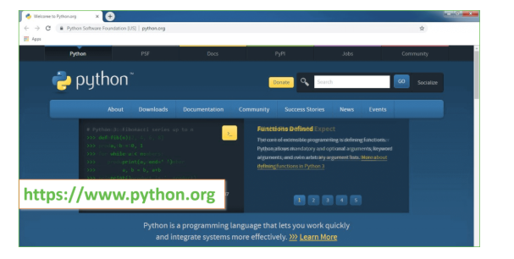

Now, check for the latest and the correct version for your operating system.

**Step 2:** Click on the Download Tab.

**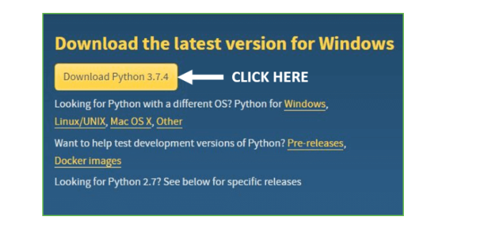**

**Step 3:** You can either select the Download Python for windows 3.7.4 button in Yellow Color or you can scroll further down and click on download with respective to their version. Here, we are downloading the most recent python version for windows 3.7.4

**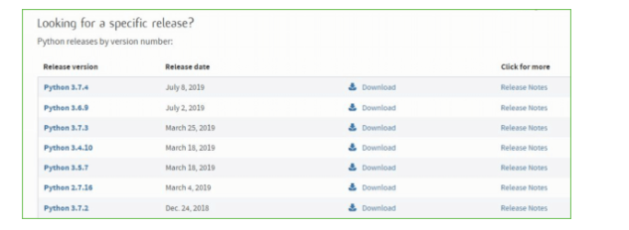**

**Step 4:** Scroll down the page until you find the Files option.

**Step 5:** Here you see a different version of python along with the operating system.

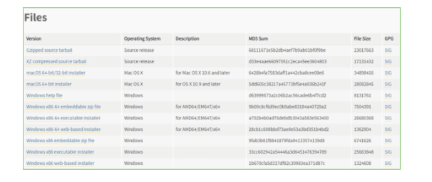

• To download Windows 32-bit python, you can select any one from the three options: Windows x86 embeddable zip file, Windows x86 executable installer or Windows x86 web-based installer.

•To download Windows 64-bit python, you can select any one from the three options: Windows x86-64 embeddable zip file, Windows x86-64 executable installer or Windows x86-64 web-based installer.

Here we will install Windows x86-64 web-based installer. Here your first part regarding which version of python is to be downloaded is completed. Now we move ahead with the second part in installing python i.e. Installation

**Note:** To know the changes or updates that are made in the version you can click on the Release Note Option.

### Installation of Python

**Step 1:** Go to Download and Open the downloaded python version to carry out the installation process.

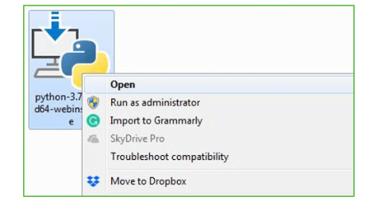

**Step 2:** Before you click on Install Now, Make sure to put a tick on Add Python 3.7 to PATH.

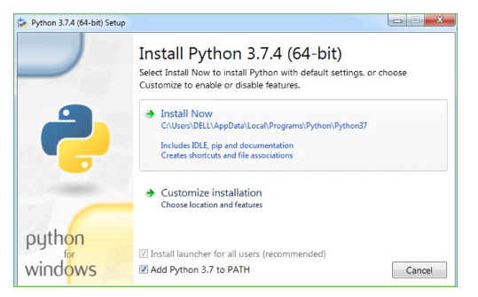

**Step 3:** Click on Install NOW After the installation is successful. Click on Close.

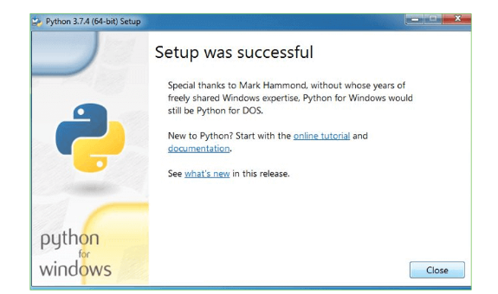

With these above three steps on python installation, you have successfully and correctly installed Python. Now is the time to verify the installation.

**Note:** The installation process might take a couple of minutes.

### Verify the Python Installation

**Step 1:** Click on Start

**Step 2:** In the Windows Run Command, type “cmd”.

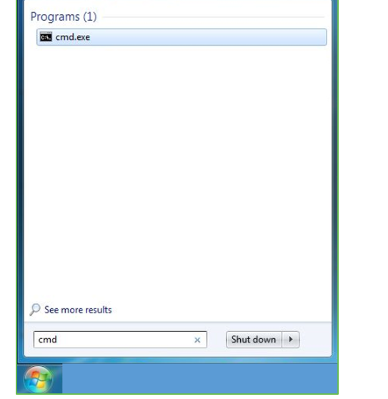

**Step 3:** Open the Command prompt option.

**Step 4:** Let us test whether the python is correctly installed. Type **python –V** and press Enter.

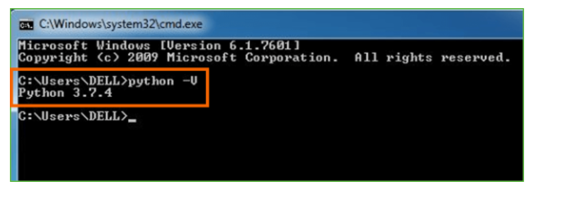

**Step 5:** You will get the answer as 3.7.4

**Note:** If you have any of the earlier versions of Python already installed. You must first uninstall the earlier version and then install the new one.

### Check how the Python IDLE works

**Step 1:** Click on Start

**Step 2:** In the Windows Run command, type “python idle”.

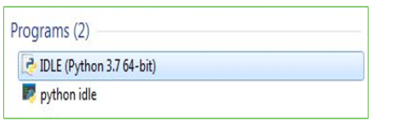

**Step 3:** Click on IDLE (Python 3.7 64-bit) and launch the program

**Step 4:** To go ahead with working in IDLE you must first save the file. **Click on File > Click on Save**

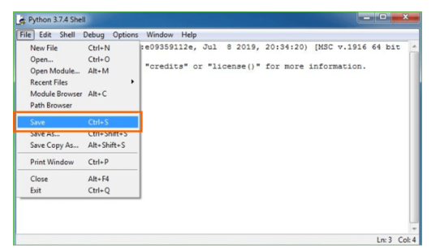

**Step 5:** Name the file and save as type should be Python files. Click on SAVE. Here I have named the files as Hey World.

**Step 6:** Now for e.g. **enter print**

**6.SYSTEM TEST**

The purpose of testing is to discover errors. Testing is the process of trying to discover every conceivable fault or weakness in a work product. It provides a way to check the functionality of components, sub assemblies, assemblies and/or a finished product It is the process of exercising software with the intent of ensuring that the Software system meets its requirements and user expectations and does not fail in an unacceptable manner. There are various types of test. Each test type addresses a specific testing requirement.

### TYPES OF TESTS

**Unit testing**

Unit testing involves the design of test cases that validate that the internal program logic is functioning properly, and that program inputs produce valid outputs. All decision branches and internal code flow should be validated. It is the testing of individual software units of the application .it is done after the completion of an individual unit before integration. This is a structural testing, that relies on knowledge of its construction and is invasive. Unit tests perform basic tests at component level and test a specific business process, application, and/or system configuration. Unit tests ensure that each unique path of a business process performs accurately to the documented specifications and contains clearly defined inputs and expected results.

**Integration testing**

Integration tests are designed to test integrated software components to determine if they actually run as one program. Testing is event driven and is more concerned with the basic outcome of screens or fields. Integration tests demonstrate that although the components were individually satisfaction, as shown by successfully unit testing, the combination of components is correct and consistent. Integration testing is specifically aimed at exposing the problems that arise from the combination of components.

**Functional test**

Functional tests provide systematic demonstrations that functions tested are available as specified by the business and technical requirements, system documentation, and user manuals.

Functional testing is centered on the following items:

Valid Input : identified classes of valid input must be accepted.

Invalid Input : identified classes of invalid input must be rejected.

Functions : identified functions must be exercised.

Output : identified classes of application outputs must be exercised.

Systems/Procedures : interfacing systems or procedures must be invoked.

Organization and preparation of functional tests is focused on requirements, key functions, or special test cases. In addition, systematic coverage pertaining to identify Business process flows; data fields, predefined processes, and successive processes must be considered for testing. Before functional testing is complete, additional tests are identified and the effective value of current tests is determined.

**System Test**

System testing ensures that the entire integrated software system meets requirements. It tests a configuration to ensure known and predictable results. An example of system testing is the configuration oriented system integration test. System testing is based on process descriptions and flows, emphasizing pre-driven process links and integration points.

**White Box Testing**

White Box Testing is a testing in which in which the software tester has knowledge of the inner workings, structure and language of the software, or at least its purpose. It is purpose. It is used to test areas that cannot be reached from a black box level.

**Black Box Testing**

Black Box Testing is testing the software without any knowledge of the inner workings, structure or language of the module being tested. Black box tests, as most other kinds of tests, must be written from a definitive source document, such as specification or requirements document, such as specification or requirements document. It is a testing in which the software under test is treated, as a black box .you cannot “see” into it. The test provides inputs and responds to outputs without considering how the software works.

**Unit Testing**

Unit testing is usually conducted as part of a combined code and unit test phase of the software lifecycle, although it is not uncommon for coding and unit testing to be conducted as two distinct phases.

**Test strategy and approach**

Field testing will be performed manually and functional tests will be written in detail.

**Test objectives**

* All field entries must work properly.
* Pages must be activated from the identified link.
* The entry screen, messages and responses must not be delayed.

**Features to be tested**

* Verify that the entries are of the correct format
* No duplicate entries should be allowed
* All links should take the user to the correct page.

# Integration Testing

Software integration testing is the incremental integration testing of two or more integrated software components on a single platform to produce failures caused by interface defects.

The task of the integration test is to check that components or software applications, e.g. components in a software system or – one step up – software applications at the company level – interact without error.

**Test Results:** All the test cases mentioned above passed successfully. No defects encountered.

**Acceptance Testing**

User Acceptance Testing is a critical phase of any project and requires significant participation by the end user. It also ensures that the system meets the functional requirements.

**Test Results:** All the test cases mentioned above passed successfully. No defects encountered.

**SCREENSHOTS:**

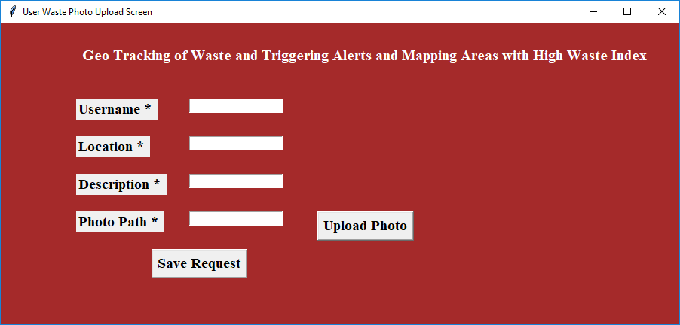

Using above screen user will enter location details with waste upload image

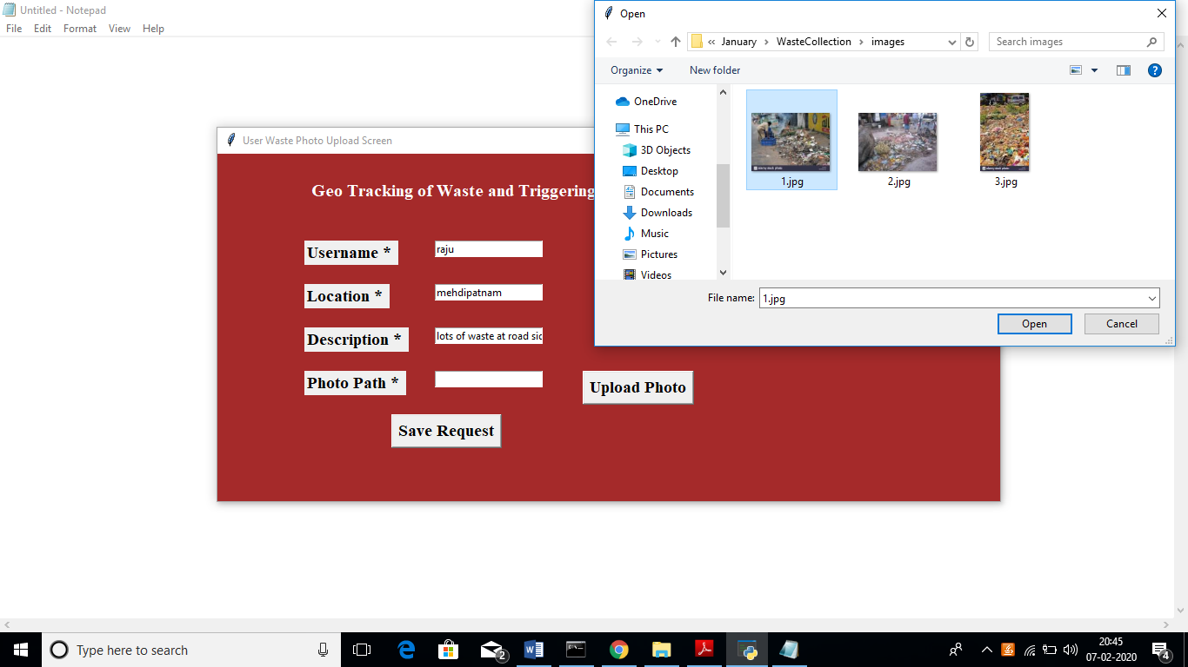

In above screen I entered some details and uploading waste image, after upload image will get below screen

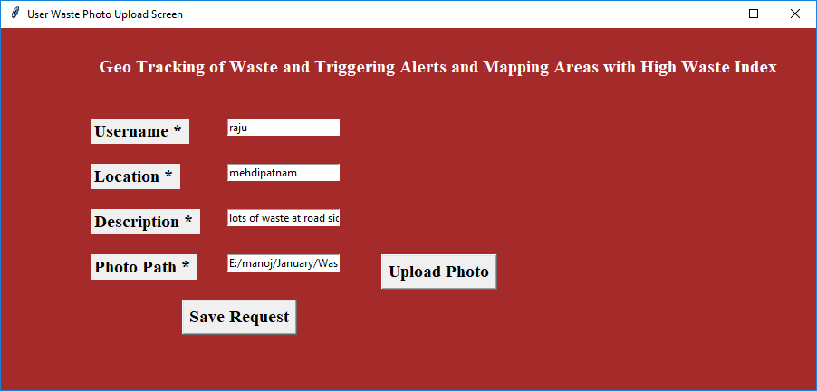

Now click on ‘Save Request’ button to send request to waste collectors

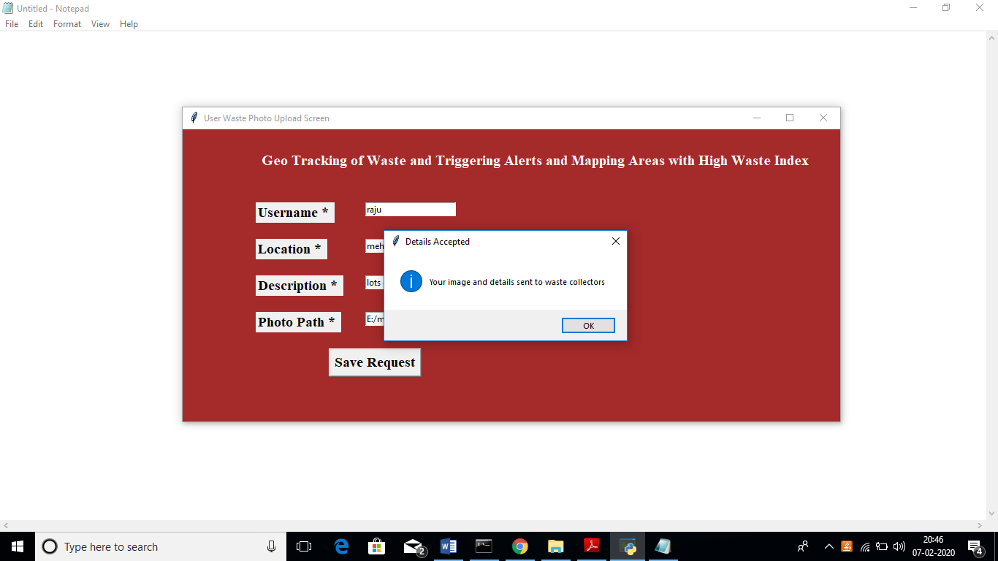

In above screen we can see user request details saved. Now close this application and run waste collector module by double click on ‘Run\_Waste\_Collector.bat’ file to get below screen

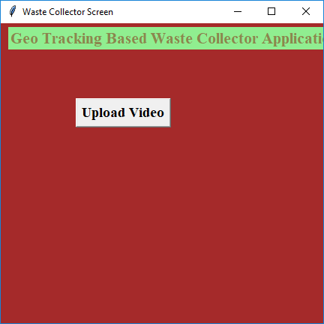

In above screen click on ‘Upload Video’ button and upload video

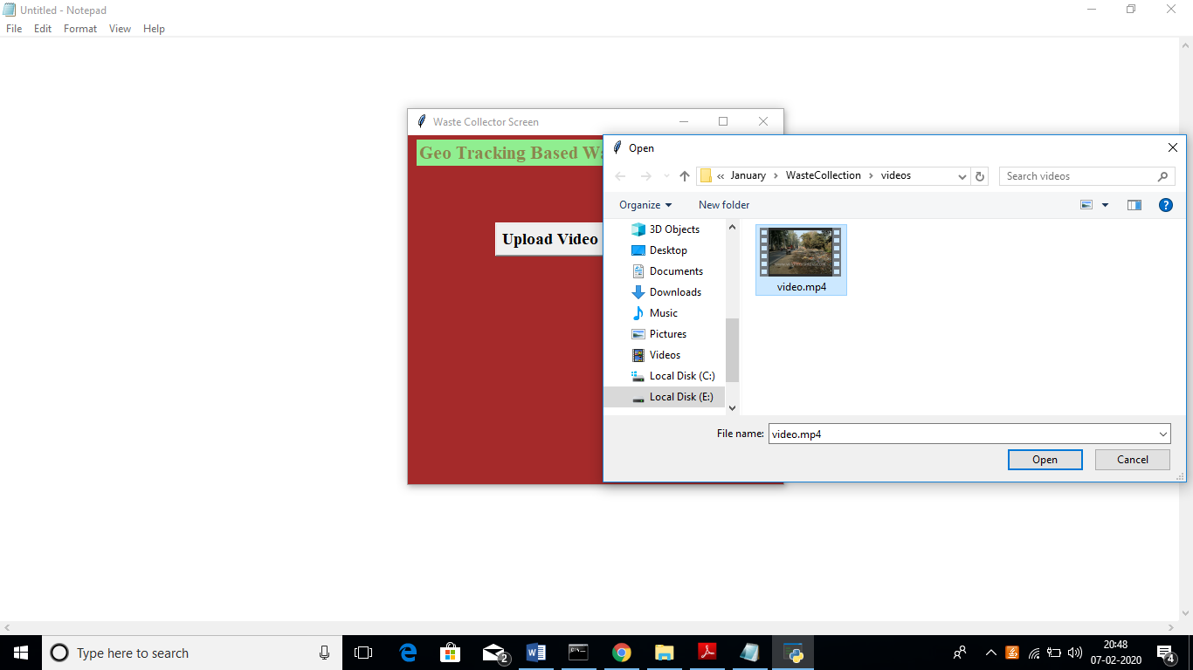

In above screen I am uploading one video and after uploading video will get below screen

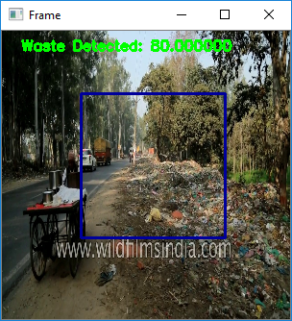

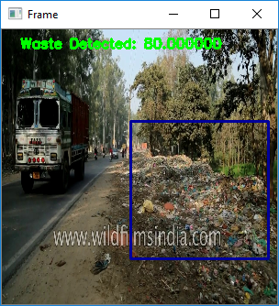

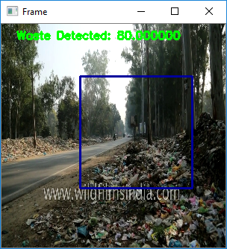

In above screen video starts playing and simultaneously it starts matching pattern with images to inform waste collectors.

**CONCLUSION :**

A system that helps in effective waste management at public and private places is designed, developed and tested. The system identifies waste level in the dustbin, triggers SMS and mail alerts when the dustbin is full, identifies areas which have full dustbins and finds an optimal route for collecting the garbage from the dustbins. The cost of the system is 4000 INR and can be easily fitted in existing private and public dustbins. The experimental results reveal that the system is easy to use, accurate, power-efficient and cost-effective.

**REFERENCES :**

[1] Sunil Kumar, Stephen R. Smith, Geoff Fowler, Costas Velis, S. Jyoti Kumar, Shashi Arya, Rena, Rakesh Kumar, and Christopher Cheeseman, "Challenges and opportunities associated with waste management in India," NCIB, [Online]. Available: https://www.ncbi.nlm.nih.gov/pmc/articles/PMC5383819/. [Accessed 20 1 2020].

[2] Balamurugan S, Abhishek A, Snehal Ratnakaran, S. Balaji, R. Marimuthu, "Design of Smart Waste Management System," IEEE, 2017.

[3] Michael Christopher Xenya, Emmanuel D’souza, Koffie-Ocloo D. Woelorm Robert Nii Adjei-Laryea, Ekow Baah-Nyarkoh, "A Proposed IoT Based Smart Waste Bin Management System with An Optimized Route: A Case Study of Ghana," IEEE, 2020.

[4] Maher Arebey, M A Hannan1, Hassan Basri, Huda Abdullah, "A SmartWaste Management Solution Geared towards Citizens," MDPI, pp. 1-15, 2020.

[5] Kellow Pardini, Joel Rodrigues, Ousmane Diallo, Ashok Kumar Das,Victor Hugo C. de Albuquerque, Sergei A. Kozlov, "Solid Waste Monitoring and Management using RFID, GIS and GSM," IEEE, pp. 27-40, 2009.

[6] "Motion Sensor Waste Bin Dry & Wet Smart Dustbin," Reetrix, [Online]. Available: https://www.amazon.in/Reetrix%C2%AE-MotionSensor-Waste-Dustbin/dp/B07R84VB5D. [Accessed 18 2 2020].

[7] "IoT based Smart Waste Management System using Arduino," Pantech Solutions, 8 12 2018. [Online]. Available: https://www.pantechsolutions.net/iot-based-smart-waste-managementsystem-for-smart-city. [Accessed 16 2 2020].

[8] "Arduino UNO data sheet," Farnell, [Online]. Available: https://www.farnell.com/datasheets/1682209.pdf. [Accessed 20 1 2020].

[9] "ESP 8266 data sheet," Components 101, [Online]. Available: https://components101.com/development-boards/nodemcu-esp8266- pinout-features-and-datasheet. [Accessed 20 1 2020].

[10] "Ultrasonic Sensor Datasheet," Electro Schematics, [Online]. Available: https://www.electroschematics.com/wpcontent/uploads/2013/07/HCSR04-datasheet-version-1.pdf. [Accessed 20 1 2020].

[11] "Servo Motor data sheet," Components 101, [Online]. Available: https://components101.com/servo-motor-basics-pinout-datasheet. [Accessed 20 1 2020].

[12] "MPU 3250 Datasheet," Invensense, [Online]. Available: https://invensense.tdk.com/wp-content/uploads/2015/02/PS-MPU9250A-01-v1.1.pdf. [Accessed 20 1 2020].

[13] "Bluetooth Module Datasheet," Components 101, [Online]. Available: https://components101.com/wireless/hc-05-bluetooth-module. [Accessed 20 1 2020].

[14] "XBee Module Datasheet," Components 101, [Online]. Available: https://components101.com/wireless/xbee-s2c-module-pinoutdatasheet. [Accessed 20 1 2020].

[15] "Blynk," Blynk, [Online]. Available: https://blynk.io/. [Accessed 5 2 2020].

[16] "MIT App Inventor: Objectives, Design, and Development," Springer, [Online]. Available: https://link.springer.com/chapter/10.1007/978- 981-13-6528-7\_3. [Accessed 5 2 2020].

[17] "How to configure as Coordinator , Router / End Device," alselectro, [Online]. Available: https://alselectro.wordpress.com/tag/s2c-zigbee/. [Accessed 5 2 2020].

[18] "Google OR Tools-A Guide," Google OR Tools, [Online]. Available: https://medium.com/google-or-tools/google-or-tools-a-guide39f439a5cd0f. [Accessed 15 3 2020].

[19] "Traveling Salesman Problem," Google OR Tools, [Online]. Available: https://developers.google.com/optimization/routing/tsp#dist\_matrix\_da ta. [Accessed 15 3 2020].

[20] "Developer Guide," Google Maps, [Online]. Available: https://developers.google.com/maps/documentation/urls/guide#directio ns-examples-using-waypoints. [Accessed 15 3 2020].